**Vanishing Gradient in RNN**

In deep neural network it is very difficult to affect the weights in Back propogation due to vanishing gradients.

Difficult to NN to memorize (singular, plural) the pattern.

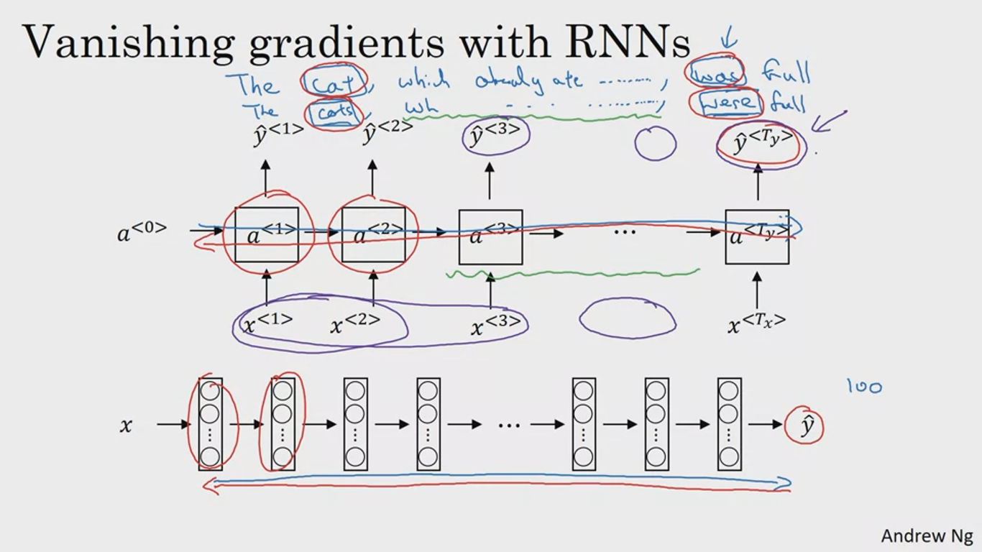

Cannot capture long range dependencies

vanishing gradient is large problem in RNN

**Exploding gradients**

Apply gradient clipping to overcome exploding gradients